**UNIVERSITI MALAYSIA TERENGGANU**

**CSM3023 – WEB BASED APPLICATION**

**BACHELOR OF COMPUTER SCIENCE (MOBILE COMPUTING) WITH HONORS**

**LAB 1 – Introduction to Servlet, JSP and MySQL Database**

**SEMESTER II 2023/2024**

**Prepared for:**

DR MOHAMAD NOR BIN HASSAN

**Prepared by:**

MUHAMMAD NOR IQBAL BIN ABDUL RAUF

(S67614)

**Task 1**

**Reflection**

**What have you learnt from this exercise?**

I learned how to install and configure xampp to use tomcat and mysql.

**Task 2**

**Reflection**

**What have you learned from this exercise?**

I have learned how to change mysql password by using command prompt.

**Task 5**

**Before modification:**

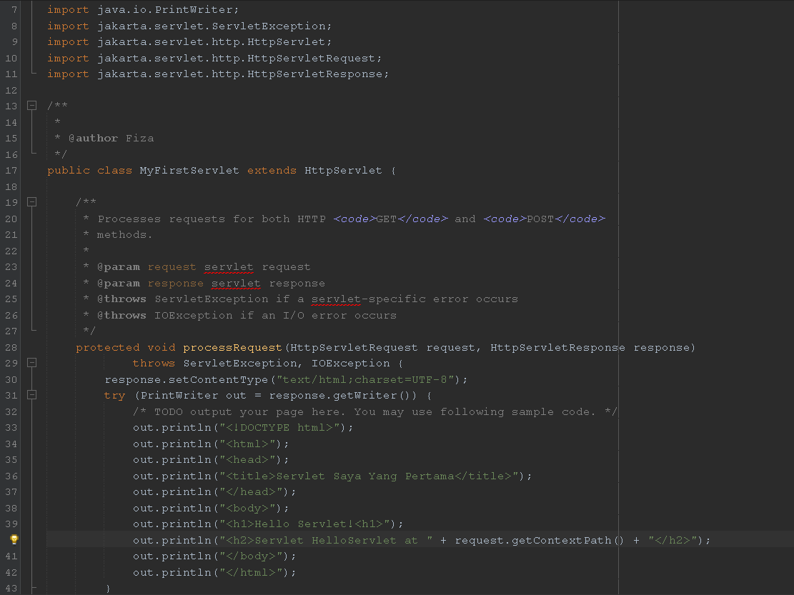

**Output:**

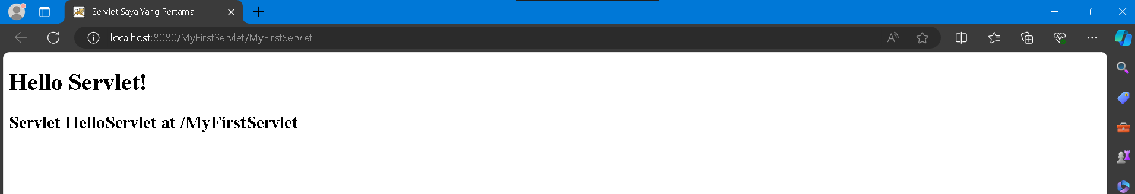

**After modification:**

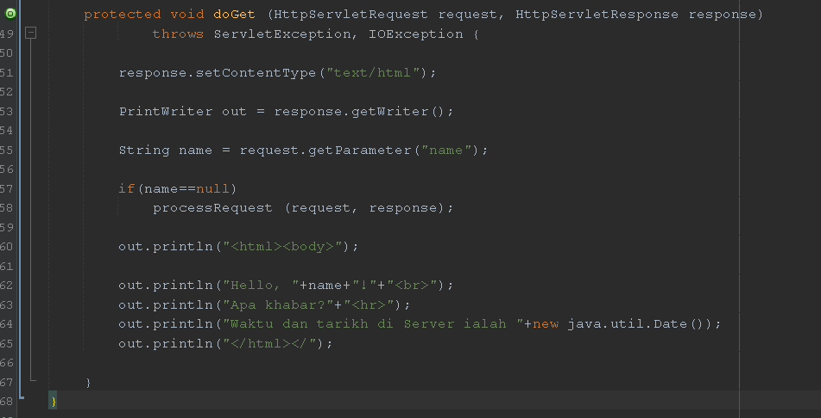

**Output:**

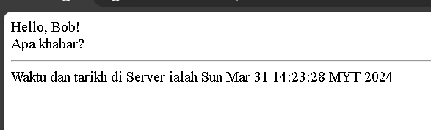

When there are no parameter, the output will show same as before modification because both call processRequest method.

**Task 6**

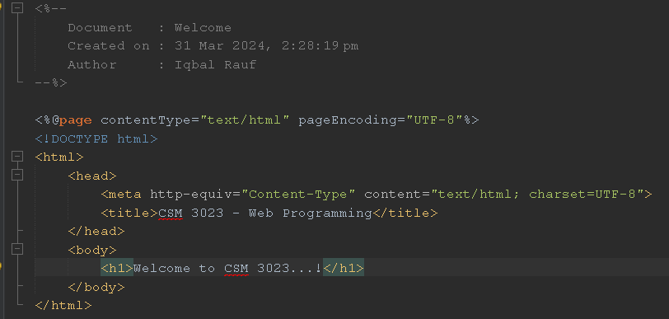

**Output:**

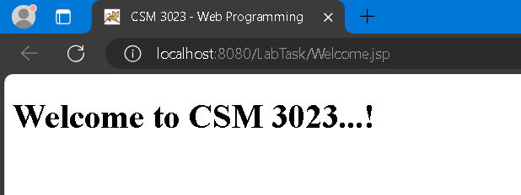

**Reflection**

**1. What have you learned from this exercise?**

I have learned how to make JSP page by using html syntax.

**2. Explain the general concept of how the JSP’s file work?**

JSP is dynamic web page that is returned when client make http request to the web server.

**3. Based on your observation of the previous tasks (Task 3 and Task 4), what are the differences you can find between servlet and JSP?**

Servlet is mediator to create dynamic web content while JSP is dynamic web page returned when client request resources from the web server, it also allow for embedding java code inside html code.

**Task 7**

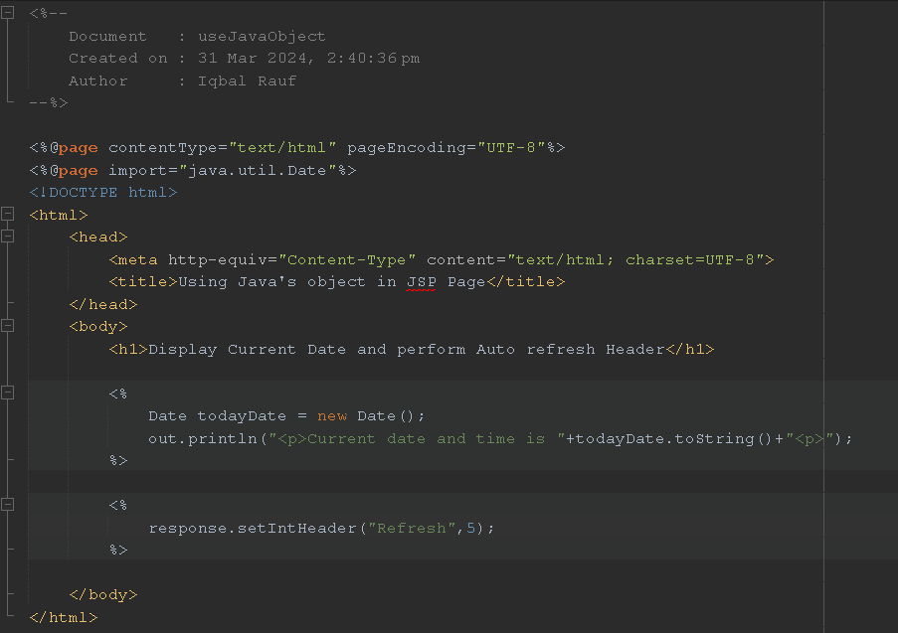

**Output:**

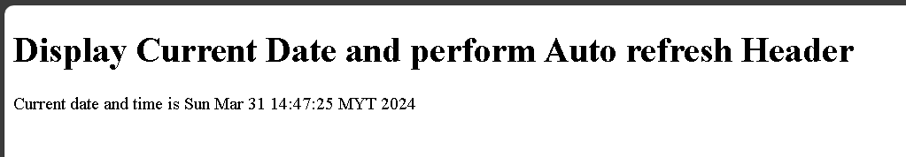

**Reflection**

**1. What have you learnt from this exercise?**

I have learned how to create a JSP page that can refresh automatically within a specific time.

**2. What is Java Scriplet?**

Java Scriplet is java code that we write inside the JSP page source code.

**3. How to use Java code in your JSP’s page?**

By surrounding the java code within the <%% and %> tag.

**Task 8**

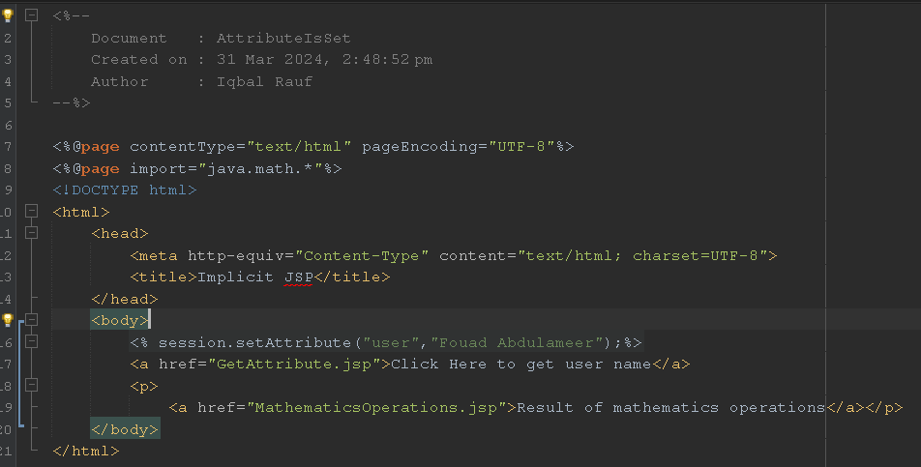

**Output:**

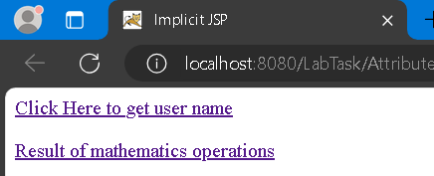

**Get Attribute JSP page**

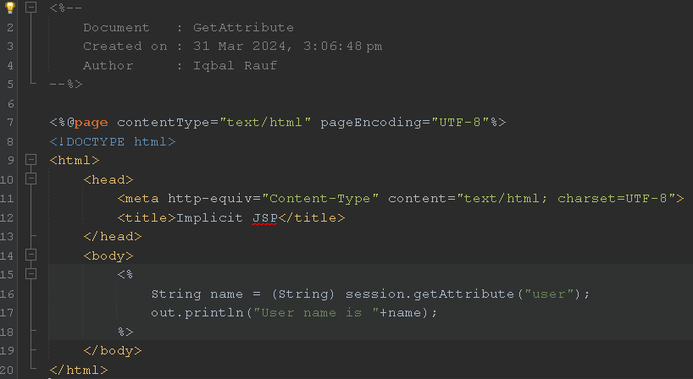

**After GetAttribute JSP page is created, Link is clicked:**

**MathematicsOperations JSP page:**

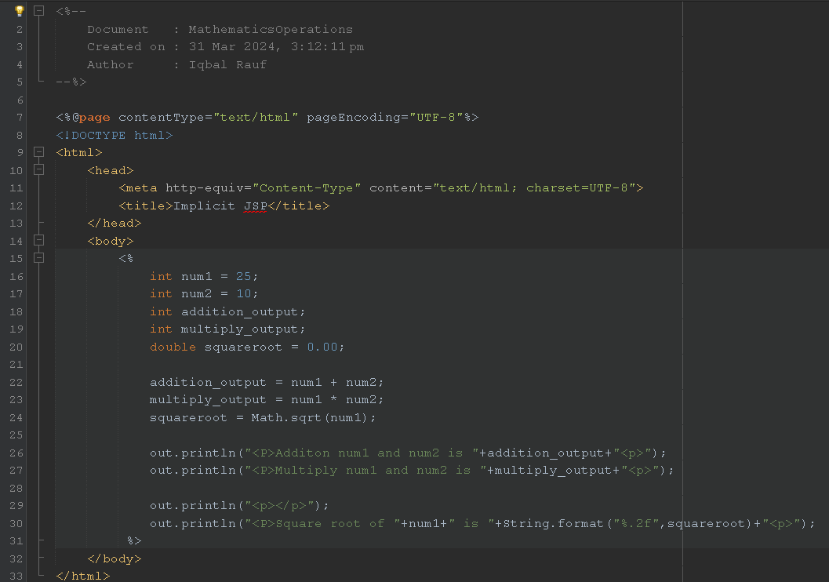

**Output:**

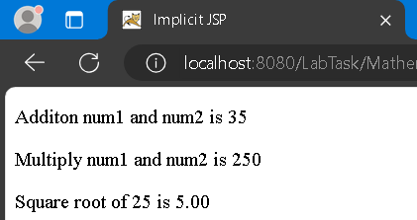

**Reflection**

**1. How do you want to submit specific information from one form to next form?**

By calling set and get method.

**2. What happened if the field name you specify in request.getParameter (“field_name”) in the second page is different from the field name you defined in the first page?**

Error encountered because the requested paremeter does not existed.

**Task 9**

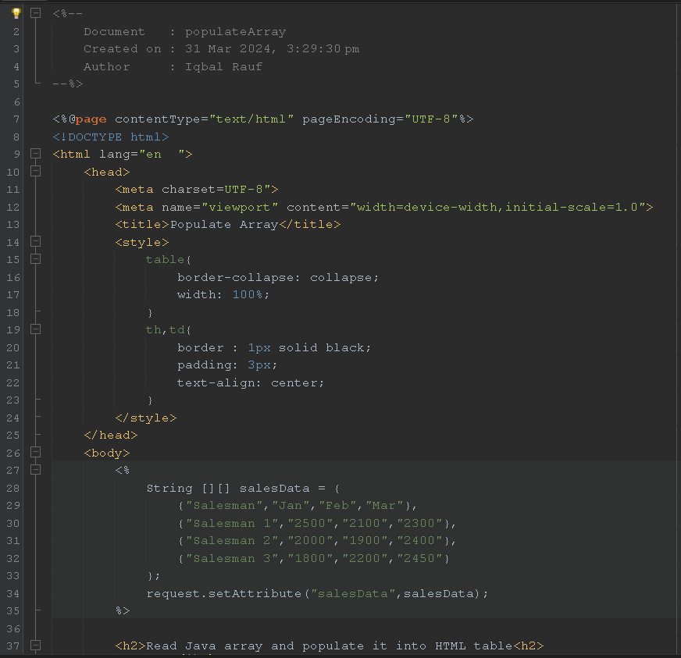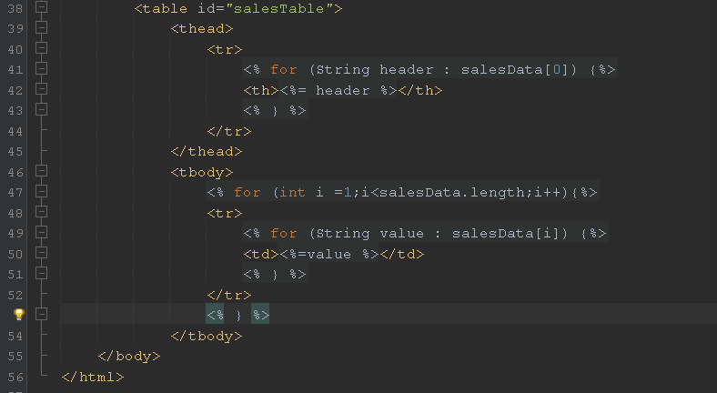

**Output:**

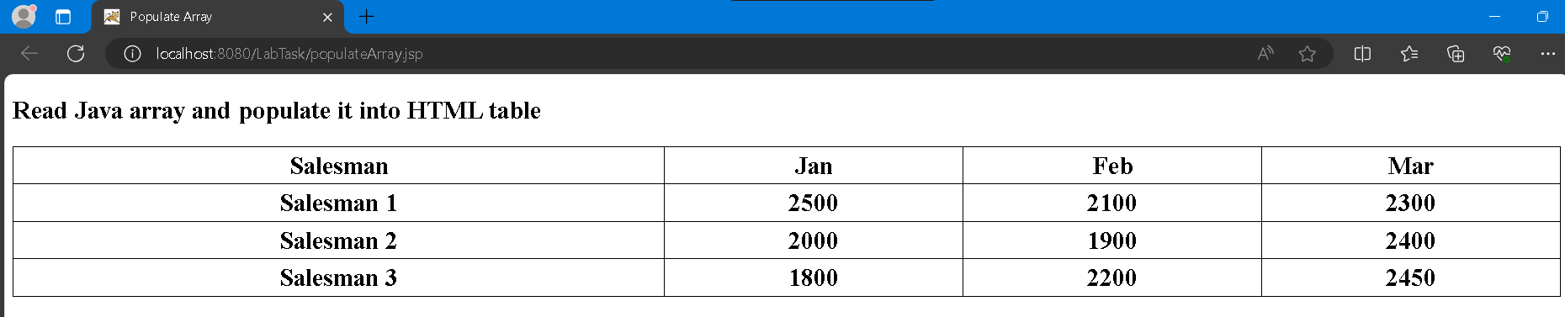

**Reflection**

**1. Write a sample syntax to declare 2D Java array.**

int[][] sales;

**2. Define a sequence of steps on how you accomplish Task 7.**

Create the table in html then fill each cell with element from the 2d array declared before.

**3. What is the difference between HTML’s page and JSP’s page?**

Html page is static page while JSP page is dynamic page that returned when client request resources from the web server.

**Exercise 1**

**calculateArea.jsp**

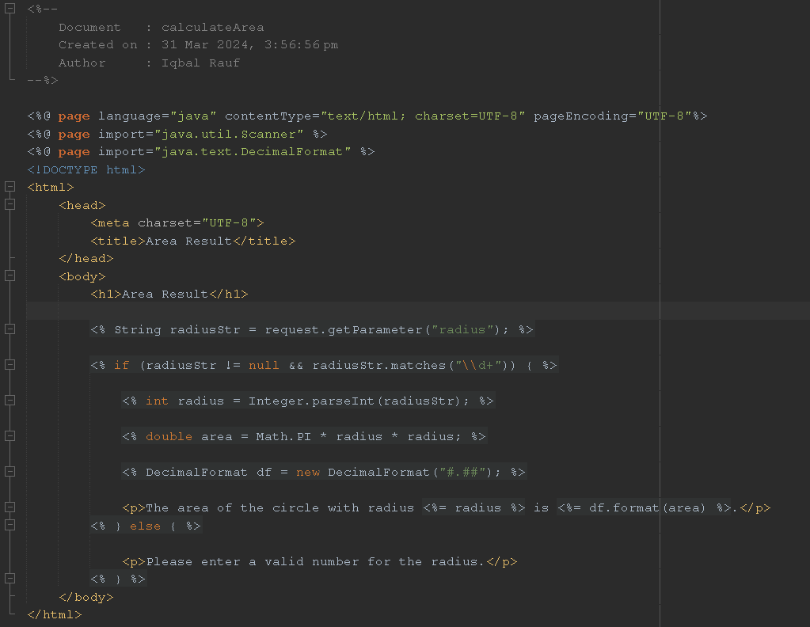

**calculateRadius.jsp**

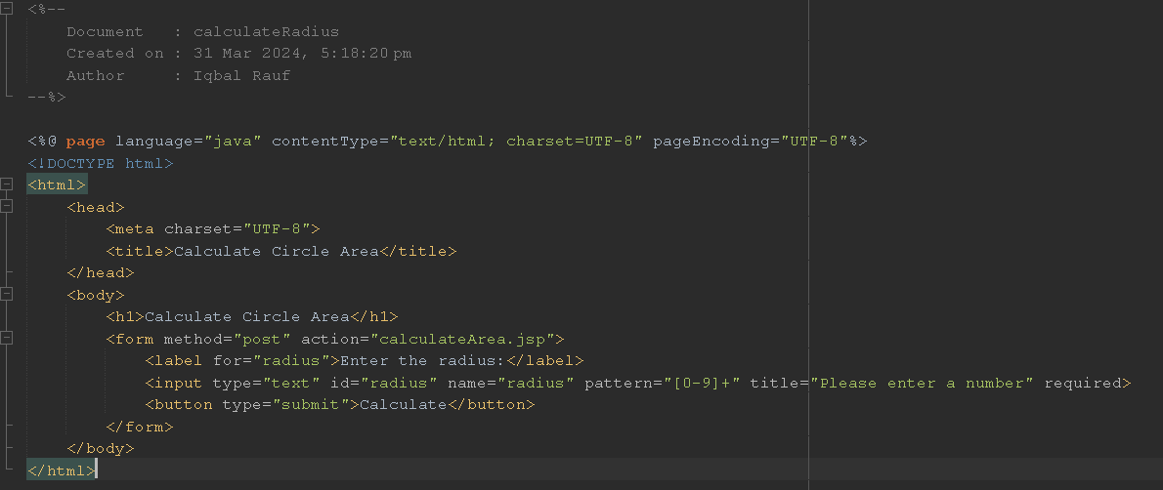

**Output:**

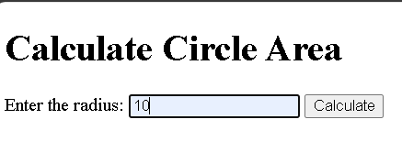

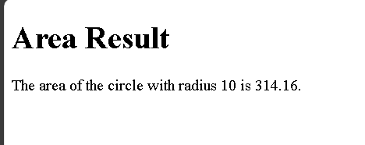

**Exercise 2**

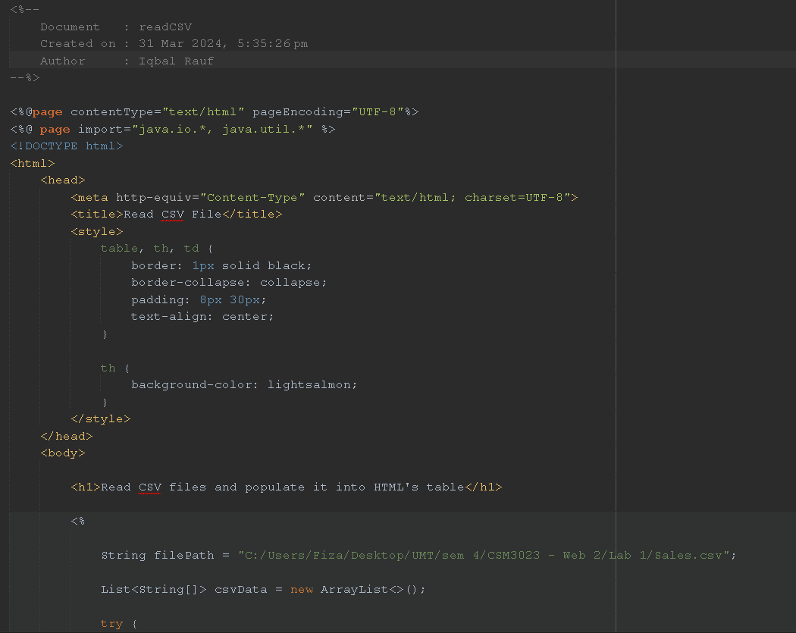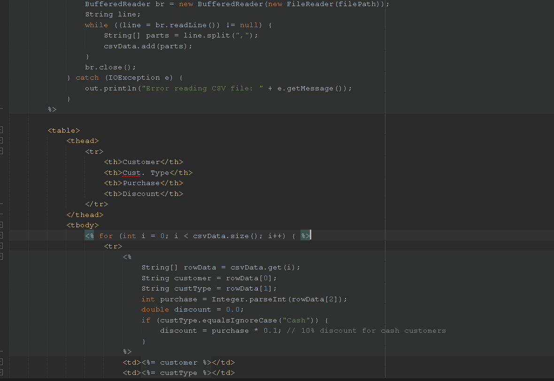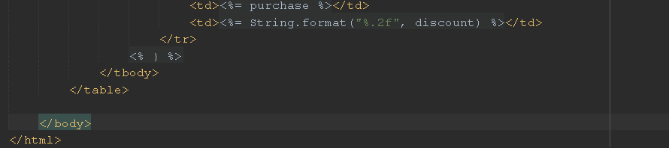

**Output:**

